### **A Smiling Jack-O-Lantern Pumpkin**

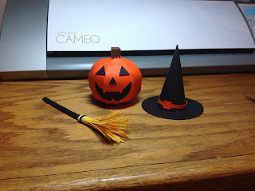

As a child, I always loved to draw a smiling jack-o-lantern face on my pumpkin for Halloween. I recreated my memories of that pumpkin in this model. It was created with 11 elliptical shapes with tabs.

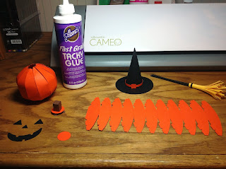

Glue the model into a circle first.

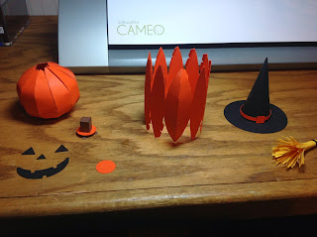

Please be patient and allow the glue to dry before proceeding to glue each segment together. When there are three segments left to glue, make the stem and insert it into the middle of the pumpkin.

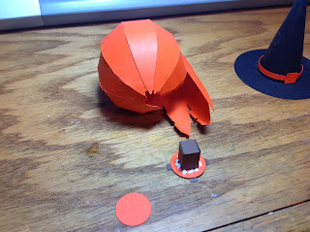

Continue gluing the elliptical shapes, one at a time and allow the tabs to dry before proceeding to the next tab.

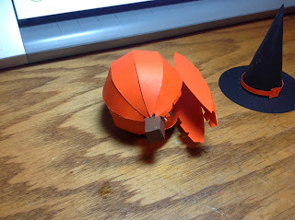

Glue the circle to the bottom of the pumpkin.

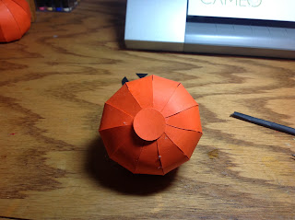

Add the jack-o-lantern face to complete the pumpkin.

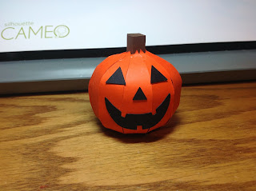

You can add a witch's hat and broom to the pumpkin. I designed them in a previous post <http://papercraftetc.blogspot.com/2013/10/halloween-witchs-or-wizards-hats.html>It is the cone net hat and witch's broom that is displayed in the photograph below.

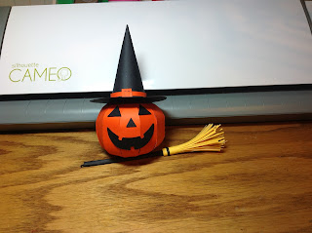

I used cardstock to create the model.